Year 2, 3 and 4 writing and reading overview 2026-27
 | Autumn 1 |  | Autumn 2
Writing | 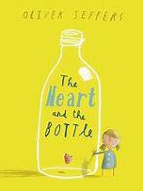 | 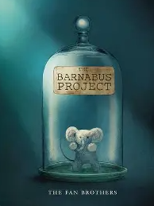 | 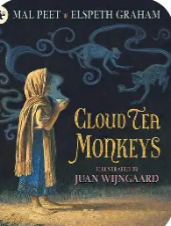 | 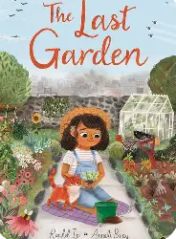
 | Own version 'dilemma' narrative Dialogue, postcard, character description, diary entry, poetry, letter of advice | Brochure Instructional writing (escape plan, experiment), descriptions, advertisements, letters of advice, dialogue | Non-chronological report Descriptive passage, writing in role, 'how to' guide (instructions), letter, discussion | Own version extended narrative Setting descriptions, advertisement/poster, retelling, instructional flyer, online response, dialogue
Reading roots
 | 2 weeks  Alternative traditional Tale | 3 weeks  Fiction | 3 1\2 weeks  Set at Central  Fiction | 2 weeks  Non fiction
 | Spring 1 |  | Spring 2
 | 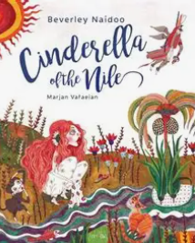 | 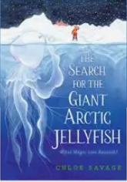
Writing | Own version traditional tale Short news report, diary entry, character description, advert | Non-chronological report Expedition proposals, persuasive letters, letters, diary entries, poetry, speech bubbles | A motivational leaflet about future dreams and aspirations  Poetry, future dreams and aspirations, setting description, letter of advice, paper aeroplane message, character description, speech aspirations  Poetry, future dreams and aspirations, setting description, letter e message, character description, speech | Newspaper Article Shared poem, diary entry, persuasive poster, letter of explanation, discussion
Reading
 | 3 weeks  Set at Central  Fiction | 3 weeks  Non fiction | 3 weeks  Fiction | 2 weeks  Poetry
 | Summer 1 |  | Summer 2
Writing
 | Prequel Lost posters, dialogue, setting and character descriptions, ledger entries, instructions, letters of warning | Own version legends Information booklets, retelling from a different perspective, letters, tourist guides | Biography of Harvey Milk Thought bubbles, speech, simple leaflet | Sequel story Retellings, recounts (postcards),setting descriptions, diary entries, instructions
Reading
 | 3 weeks  Fiction | 3 weeks  non fiction | Set at Central  Fiction | 2 weeks  Poetry

